High Level Design
Introduction:
Task:
Implement the data structure for storing an n-ary tree that represents hierarchical data.
Each level of the tree is constrained to the corresponding level of a hierarchy.

Write an algorithm to:
1. detect the level of elements in each input set
2. Find sub-tree intersection: print elements from the lower level set(child level) such that there is an element in the other input set that is its parent.

Implementation Details:
We have created an API that will read the user input to store the tree representation and later use it to compute task of sub-intersection of the task.
SubTreeIntersection.java interface has been provided as an interface to the API.
It has methods to read and store tree data and compute the sub intersection of the given sets.
We have represented the tree using hashmap where key is the item name and value is an object of TreeElement class which is actually is a item meta data class and have following key’s (item) information: level in tree and parent of the key node.
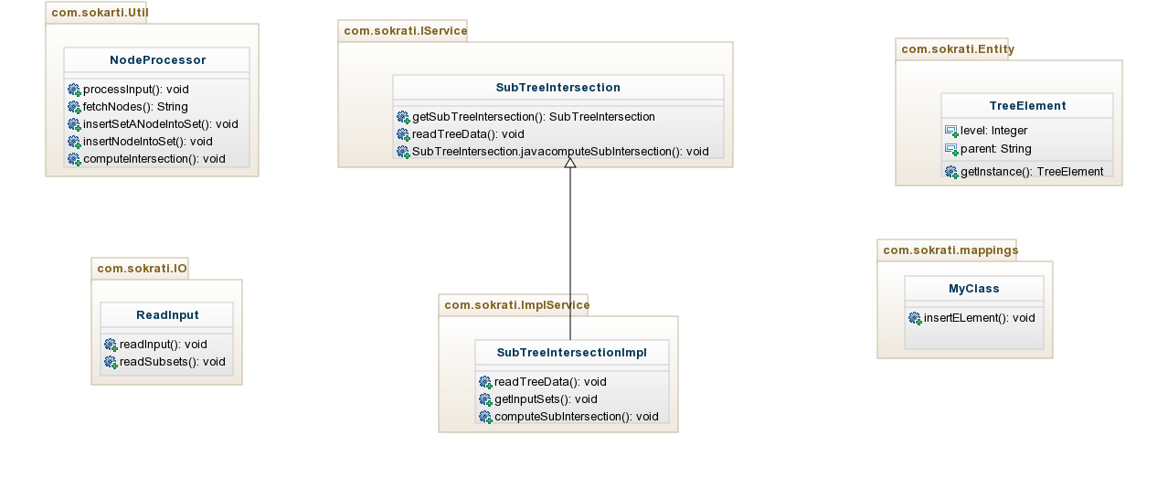
Figure: class diagram for sub intersection problem.

Item meta- data class: TreeElement.java
TreeElement class is the meta-data class for storing item information. This class has information of level of the item in the tree and parent of the item.
How Map is used to store information:
Map<String,TreeElement>
Here key is of string type: name of the item
And value is reference of object of the type TreeElement which is use to store item’s information.
From the value part, we can find the parent name and find the parent node using the parent name as key in map. Similarly, we can find parent of any item of the tree.
How to store/insert elements in map.
If node is the parent node, then initialize the level of to 1. Other fetch the level of the parent node and store in variable “level” and create the treeElement using level value as ”level+1”.

